Jurisdiction & Contacts Import Runbook

Purpose
This runbook documents the standard operating procedure for importing Jurisdiction and Contact records into OneVizion. It is intended to provide a repeatable process that can be executed by any trained team member without relying on institutional knowledge.

Scope
Applies to OneVizion users responsible for preparing, importing, validating, and maintaining Jurisdiction, Contact, and Jurisdiction-to-Contact relationship records.
Includes source file preparation, import execution, validation, error resolution, and manual record creation.

Roles & Responsibilities
User
    - Execute imports
    - Validate imported data
    - Resolve import errors
SME
    - Maintain process accuracy.
    - Validate OneVizion-specific procedures.
Data Owner
    - Provide approved source data.
    - Confirm data accuracy before importing.

Assumptions
Source data has been approved.
Users have appropriate OneVizion access.
Import templates are maintained by the process owner.

Prerequisites
Approved source spreadsheet
Access to OneVizion
Backed up source file

Preparing the Source File
- Confirm that the required columns exist in the source spreadsheet.
- Verify that the required fields are populated.
- Remove duplicate jurisdictions.
- Confirm that contacts are assigned correctly.
- Validate the approved jurisdiction types.

 | Type | Usage
 | City | Municipal governments
 | County | County governments
 | State | State agencies
 | Company | Railroad companies and private entities
 | Township | Township jurisdictions

Preparing the Import Template
- Log into OneVizion
- Click the  icon and select Import Data to open the Import Data module.
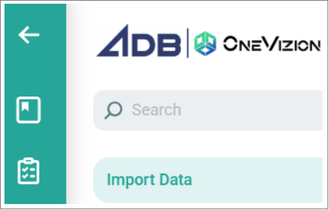

- In the Import File pane, click the Excel icon.
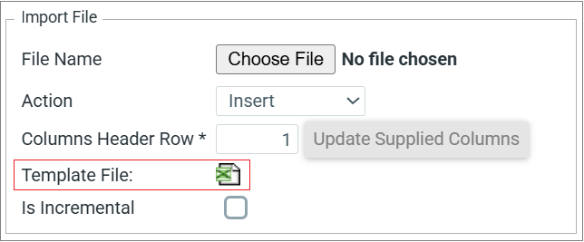
The template file is downloaded to your Downloads folder.
- Copy validated source data into the template.
- Verify all required fields align with template columns.
- Save the completed template.

Validating the Import Configuration
Before running the import, verify:
The import template matches the configured field mapping.
Source columns align with OneVizion import fields.
The selected import action matches the intended update method.
Required identifiers are populated to prevent duplicate records.
Relationship fields are mapped correctly.

Running the Import
- Navigate to the Import module.
- Select the appropriate import configuration or Import ID.
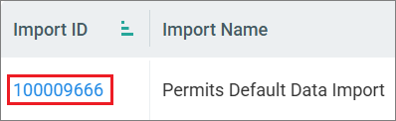
- Click Choose File and select the completed import template.
- Select the required import action:
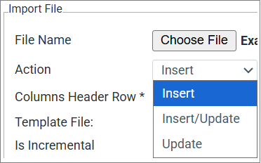
    - Insert – Creates new records.
    - Insert/Update – Creates new records and updates matching records.
    - Update – Modifies existing records.
- Click OK to upload the file.
- Review the validation results and correct any errors.
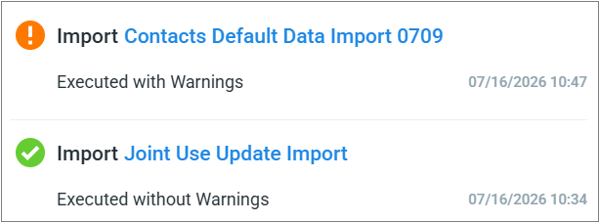
- Submit the import for processing by selecting the system action (for example, Import, Run, or Execute).
- Monitor the import status until processing is complete.
- Review the import log for warnings, errors, and successful records.

Validating the Import
- Compare source record count to imported record count.
- Review the Jurisdiction Tracker to verify the imported jurisdiction records appear correctly and required fields are populated.
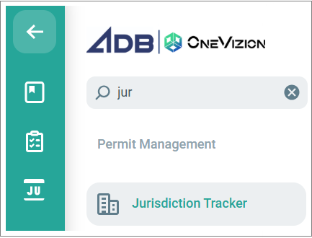
- Confirm all contacts imported successfully.
- Review the import log for warnings or failures.

Validating the Jurisdiction & Contact Relationship
- Verify that each jurisdiction is associated with the correct contact(s).
- Confirm that no contacts are assigned to an incorrect jurisdiction.
- Compare jurisdiction-to-contact relationships against the source spreadsheet to ensure they match.

Validating the Permit-to-Project
- Verify imported jurisdictions are associated with the correct projects, where applicable.
- Confirm that no orphaned permit records exist.

Resolving Errors
- Review the import log.
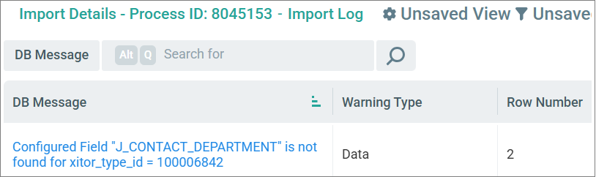
- Correct the source data.
- Reload the import template.
- Re-run the import.
- Repeat validation.

Creating a Manual Record
- Navigate to the appropriate OneVizion table.
- Create a new record.
- Populate all required fields.
- Assign the appropriate jurisdiction type.
- Associate related contacts.
- Save the record.
- Verify that the record appears correctly.

Post-Import Checklist
- Source and imported counts match.
- No validation errors remain.
- Jurisdiction relationships verified.
- Contacts verified.
- An orphan check is completed.
- Documentation updated if process changes occurred.

Document Control
Owner: | Julia Degnan
Primary SME: | Sarah Siddiqui
Secondary SME: | Mike Riley
System: | OneVizion
Version: | 0.1

Revision History
Version | Date | Author | Notes
0.1 | 7/14/2026 | Julia Degnan | Initial draft

